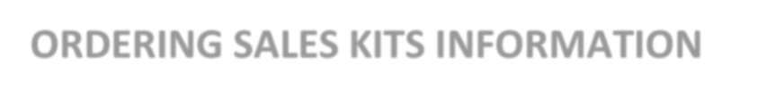

Aetna Sales Kits

- Go to https://www.aetna.com/insurance-producer.html

- Login into Producer World

- Click on Individual Medicare in the top right

- Under the plans tab to the right select the drop-down box “Quick Links”

- Select enrollment kits
    - Your NPN will be your login ID and password

