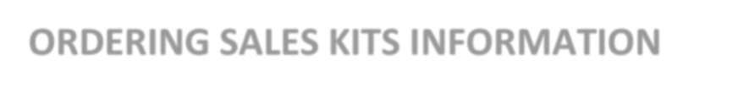

Cigna Sales Kits

- Logon to Custom Point at https://custompoint.rrd.com/ with your User ID, password and Account (hspring).

- You will select the Plan Year, State, and plan and then you will be able to order kits or download a digital copy.

