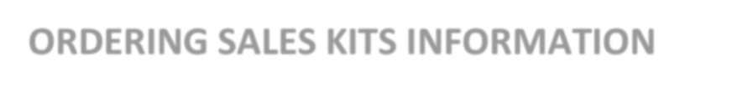

Molina Sales Kits

- Licensed agents will receive enrollment kits automatically for your Resident State.

- To order supplies for other states, contact Broker Services at 866-440-9788 or email Broker@MolinaHealthcare.com

